**Bria 5 (Softphone)  
  
Introduction**

Whilst working remotely, to contact our customers and communicate with our colleagues we use a software phone (softphone); this softphone is called Bria 5. Below shows how the interface looks.

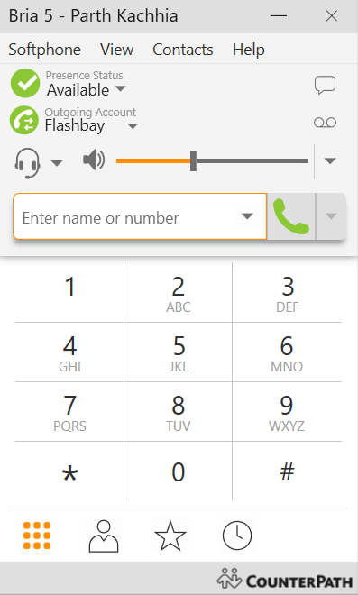

**Outgoing Calls**



To make an outgoing call, you can either use your keyboard to dial the numbers or alternatively use your mouse to select the individual numbers on the keypad.  
  
 Then press here to start the call

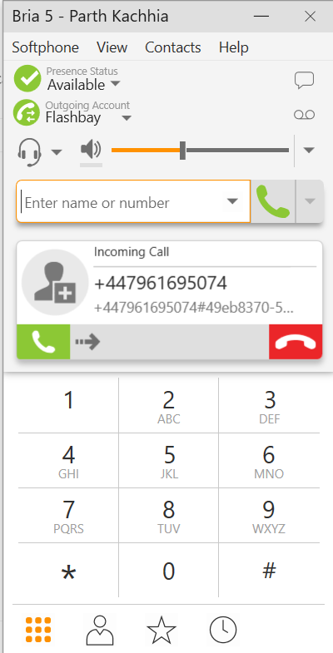**Incoming Calls**

To accept incoming calls, slide this icon fully

To end the call, press this icon

**Transferring a call**

1. 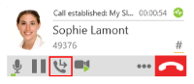Click  Transfer this call at the bottom of the call panel. The call is put on hold

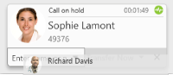 2. Type the name or number of the target

3. Click **Call First,**

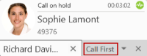

Bria 5 phones the target. When the target answers, **Transfer Now** is now enabled.

4.Speak to the target. If the target wants to take the call, click **Transfer Now** (Windows) click the **X** at the bottom of the call panel

